

**CS251 – M-Chess**

**Game**

|  |  |
| --- | --- |
| **Staff Memebers** | **Email** |
| **Dr Mohamed El Ramly** | **m.elramly@fci-cu.edu.eg** |
| Eng Catherine Bedrossian | c.bedrossian@fci-cu.edu.eg |
| Eng Sara Tarek Ali Othman | s.tarek@fci-cu.edu.eg |
| Eng Mohamed Samir | m.samir@fci-cu.edu.eg |
| Eng Marwa Nabil | m.nabil@fci-cu.edu.eg |
| Eng Yomna Magdy Mohamed | yomna@fci-cu.edu.eg |
| Eng Desoky Abd El-qawy | d.abdelqawy@fci-cu.edu.eg |
| Eng Omar Khaled Ali Ragab | o.khaled@fci-cu.edu.eg |
| Eng Mohamed Elarnaoty | m.elarnaoty@fci-cu.edu.eg |
| Eng Mostafa Saad | m.saad@fci-cu.edu.eg |

Contents

Instructions [To be removed] 3

Team 2

Document Purpose and Audience 3

System Models 4

Class diagrams 4

Sequence diagrams 5

User Interface Design 7

Screen 3 – Login Screen 7

Screen 4 – Main Interface 8

Ownership Report 8

# Team

|  |  |  |  |
| --- | --- | --- | --- |
| **ID** | **Name** | **Email** | **Mobile** |
| 20120161 | Khaled Abd-ElRahman Yehia | Assassins_doom@yahoo.com | 01099366891 |
| 20120069 | Ahmed Hzzaa’ Al-sai’d | Hzzaaahmed@gamil.com | 01111992307 |
| 20120335 | Mohamed Maher Ibrahem | Maherm221@yahoo.com | 01220463743 |
| 20120261 | Amr Adel Mohammed Khalefa | amradel525@gmail.com | 01098997611 |

# Document Purpose and Audience

* This document is a simple system requirement specifications for a multiplayer chess game

Aiming to declare the main classes, graphic user interfaces in the game.

* Audience of this document are: Software manager, project owner ,web developers, web

Designers, testers.

# 

# System Models

## Class diagrams

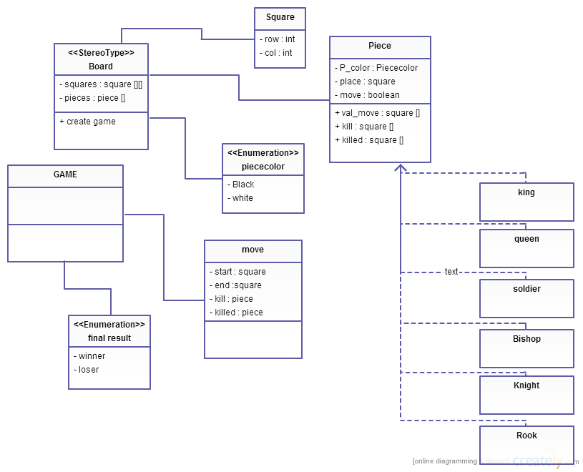

| **Class ID** | **Class Name** | **Subsystem ID** | **Description** |
| --- | --- | --- | --- |
|  |  |  |  |

## Sequence diagrams

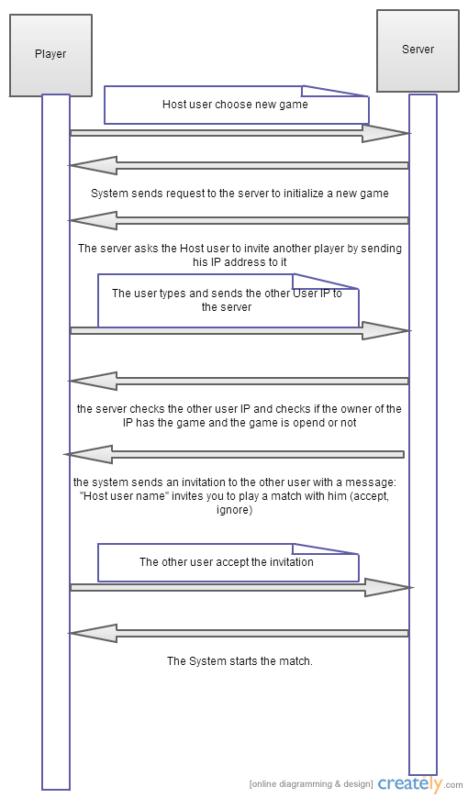

### 

## User Interface Design

### Screen 1 – Login Screen

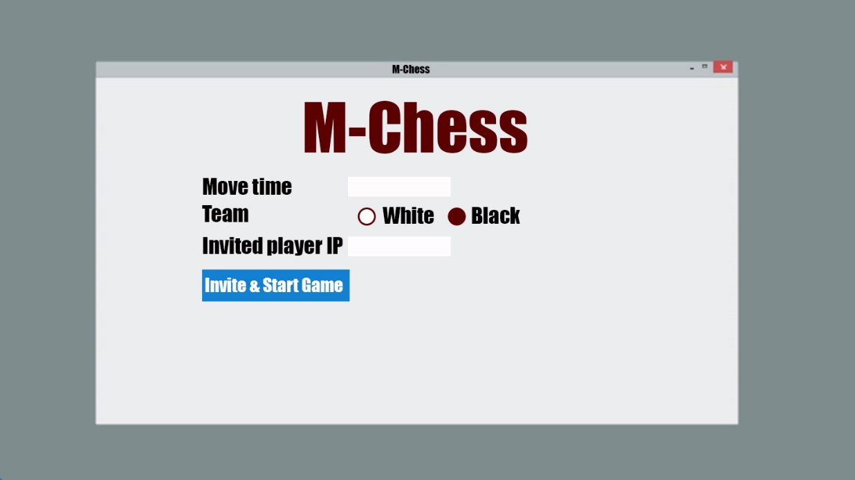

### 

### Screen 2 – Main Interface

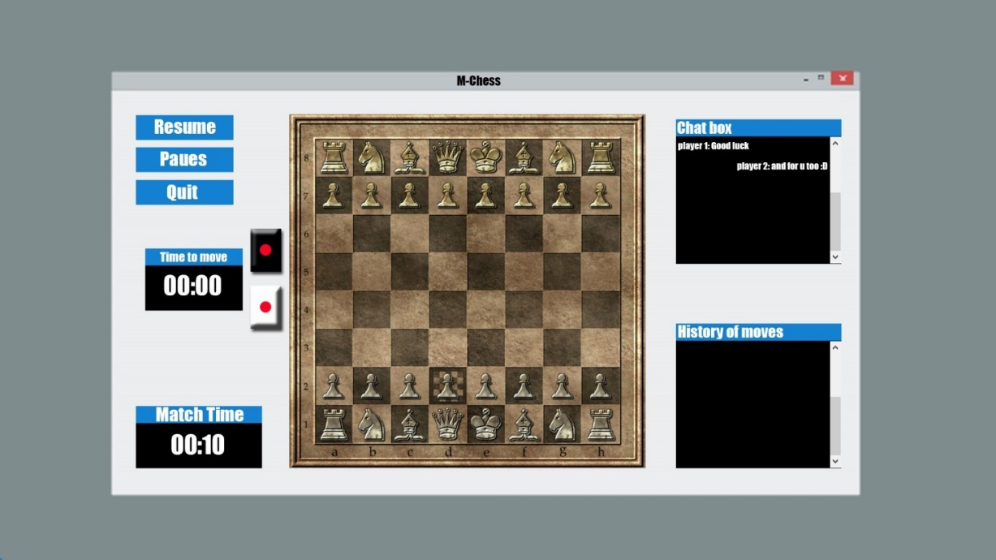

# Ownership Report

|  |  |
| --- | --- |
| **Item** | **Owners** |
| Document Purpose and Audience | Mohamed Maher Ibrahem |
| Class diagram | Ahmed Hzzaa’ Al-sai’d |
| Sequence diagram | Amr Adel Mohammed Khalefa |
| Logic screen – main interface | *Khaled Abd El-Rahman Yehia* |